LEED Power Supply Programming

Introduction

There are 3 main ways to control the LEED Power Supply by computer:

- Using the OCI LpsV2 ActiveX control,

- Using the command set (see Appendix 1) along with the OCI MyUSB automation object,

- Using the command set along with the software development kit from FTD (see the FTDI software development kit for details).
Along with this document, the package includes the C++ source code for TestLpsV2 (which hosts the LpsV2 activeX control),
the file CallMyUSB.hta (which shows how to call the MyUSB object) and the installation for the LpsV2 activeX control.
Note that the user must install the LpsV2 in order to have the MyUSB object. Also, prior to running this software, the FTDI USB drivers must be installed appropriately.

LpsV2 ActiveX control

The LpsV2 active X control consists of a window which can be included on a Visual Basic or LabView form or an Internet Explorer and/or a set of functions which can be called from code. The window display is shown below:

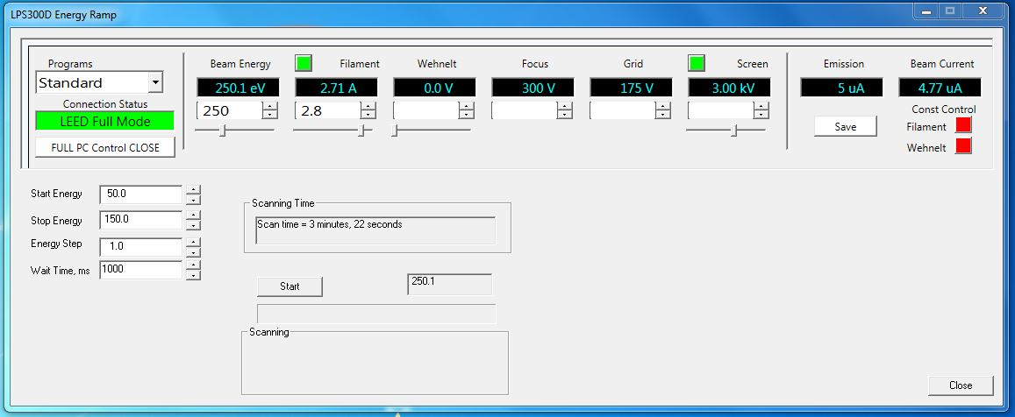

The FULL PC Control CLOSE button shuts down the USB communications. The window shows the current status of the USB connection.

On the left hand side of the window are the Beam Energy controls. The darkened window shows the current Beam Energy. The small arrow buttons allow for fine adjustment of the beam energy. The sliding control under display allows for coarse adjustment of the beam energy.

In the LEED full control mode, there are setting controls for the Filament Current, the Wehnelt, the Focus, the Grid and the Screen. The Emission and Beam Currents are read only parameters. In the LEED full control mode, the user can select programs which select the Wehnelt, Focus, and Grid voltages for selected beam energies.

The LEED power supply allows for constant beam current either by adjustment of the Filament current or by the Wehnelt Voltage. Select the desired settings using the arrow key on the bottom right hand side of the LpsV2 window.

Automatic Acquisition

- To start an automated LEED scan the LEED Power Supply has to be in PC Control Mode and connected via USB. To start select the FULL PC Control button.
- Set et the Start Energy (eV), Stop Energy (eV), and Energy Step (eV) and Wait Time. Click Start Scan to commence the scan.

LpsV2 Property Set

The LpsV2 active X control has an extensive list of properties, methods and events:

Properties

Filament - get and set property, double value

Wehnelt - get and set property, double value

BeamEnergy - get and set property, double value
Focus - get and set property, double value
Screen - get and set property, double value
BeamCurrent - readonly property, double value
EmissionCurrent - readonly property, double value
GridVoltage - get and set property, double value
AmStartedUp - get and set property, BOOL value
ConstantBeamCurrent - get and set property, long value, 0 = not constant, 1 =filament control, 2 = Wehnelt control

Using the Lps Command Set

A computer using a USB interface can control the LPS300D instrument. Appendix 1 shows the command set that is available (note that each command must be terminated by a <CR> character). For example, to set the beam energy to 50.0 eV in LEED mode, issue the command V2 0500<CR> over the USB. To help in programming the USB, OCI has developed a utility library called MyUSB.

MyUSB Library

The MyUSB library is an automation object, which simplifies communications over the USB line. The main methods available using this library are:

PortOpen – get and set property

TestComm – method, open the setup dialog

ClearComm – method clear the USB communications buffer

SendString – method send a string and optional read the received string.

GetPortDescriptions method to search the USB ports on the system, the results are returned with the event HavePortDescriptions (check your development tool on how to receive events).

The TestComm command opens the following window:

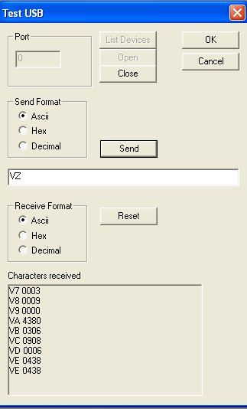

Click on the Open button to open the USB communications. Once communications is successfully set, the Open button becomes disabled.

Enter text in the edit box under the Send button (if Ascii format is selected do not enter a <CR> character). Click Send to send the command and any received characters are noted below. For this example, VZ is sent which queries all the available parameters. Click Reset the reset the window display.

For an example, see the JScript code Appendix 2, which shows how to call the MyUSB object.

Appendix 1 Lps Command Set
SETTING
-------

FILAMENT V1 3200 [mA] -> 3.20A maximum

ENERGY V2 7500 -> 750.0V in LEED maximum
V2 3200 [V] -> 3200V in AES maximum

SCREEN V3 5000 [V] -> 5000 in LEED maximum
V3 0200 [V] -> 200 in AES maximum

GRID V4 3200 [V] -> does not exist in AES mode

FOCUS V5 3200 [V]

WEHNELT V6 0400 -> 40.0V maximum

BC CONSTANT VS F - enable bc constant by filament; 'F' 0x46
max. 200mA in LEED or 20.0mA in AES
VS W - enable bc constant by wehnelt; 'W' 0x57
max. 200mA in LEED or 20.0mA in AES
VS N - bc constant off 'N' 0x4E

READING
-------

FILAMENT V7 -> V7 5000 [mA] -> 5.00A maximum

EMISSION V8 -> V8 0200 [uA] -> 200uA maximum

WEHNELT V9 -> V9 0400 -> 40.0V

ENERGY VA -> VA 7500 [V] -> 750.0V in LEED
VA -> VA 3200 [V] -> 3200V in AES

GRID VB -> VB 3200 [V]

BEAM CURRENT VC -> VC 2000 -> 20.00uA in LEED
VC -> VC 0200 -> 200uA in AES

SCREEN VD -> VD 5000 [V]

FOCUS VE -> VE 3200 [V]

STATUS VS -> VS L N F
| | |
| |'F' - full pc control mode, 'X' - external pc control mode
| |
|'F'- cbc by filament, 'W'-cbc by wehnelt, 'N'-bcc off

'A'- AES, L-LEED

READ ALL VZ -> V7 XXXX V8 XXXX V9 xxxx VA xxxx VB XXXX VC XXXX VD XXXX VE XXXX
not in AES

Appendix 2 JScript Code Calling MyUSB

<HTML>
<SCRIPT LANGUAGE = "JScript">

// MyUSB object
var g_myUSB;

// setup the USB
function setupUSB()
{
g_myUSB.TestComm(0);
}

// get the MyUSB object
function getMyUSB()
{
g_myUSB = new ActiveXObject("OCI.MyUSB.1");
}

// read the beam energy
function readBeamEnergy()
{
var rxString; // received string
var numString; // number string
var s; // position for the first blank
var nValue; // value
var fDone; // completed flag
var len; // string length

// make sure that the port is open
if (!g_myUSB.PortOpen)
{
g_myUSB.CommPort=0;
g_myUSB.PortOpen = true;
}
// send a string
rxString = g_myUSB.SendString("VA\r", true);
if (null != rxString)
{
s = rxString.indexOf(" ");
if (s > 0)
{
len = rxString.length;
i = s + 1;
fDone = false;
while (i < len && !fDone)
{
fDone = '0' != rxString.charAt(i);
if (!fDone) i++;
}
if (fDone)
{
numString = rxString.slice(i);
nValue = parseInt(numString); // convert to number
if (NaN != nValue)
{
txtBeamEnergy.value = nValue / 10.0;
}
}
}
}
}

// set the beam energy
function setBeamEnergy()
{
var txString;
var beamEnergy; // beam energy setting

// make sure that the port is open
if (!g_myUSB.PortOpen)
{
g_myUSB.CommPort=0;
g_myUSB.PortOpen = true;
}
// form the set beam energy string
beamEnergy = txtSetBeamEnergy.value;
// conditions on beam energy
if (beamEnergy >= 0.0 && beamEnergy <= 750.0)
{
beamEnergy *= 10.0;
beamEnergy = Math.ceil(beamEnergy);
if (beamEnergy >= 1000)
txString = "V2 " + beamEnergy.toString() + "\r";
else if (beamEnergy > 100)
txString = "V2 0" + beamEnergy.toString() + "\r";
else if (beamEnergy > 10)
txString = "V2 00" + beamEnergy.toString() + "\r";
else
txString = "V2 000" + beamEnergy.toString() + "\r";
g_myUSB.SendString(txString, false);
}
}

</sCRIPT>
<BODY>

<INPUT TYPE=button onclick="getMyUSB()" value="Init MyUSB">

<INPUT TYPE=button onclick="setupUSB()" value="Setup MyUSB">

<INPUT TYPE=text name="txtBeamEnergy" value = "">

<INPUT TYPE=button onClick="readBeamEnergy()" value ="Read BeamEnergy">

<INPUT TYPE=text name="txtSetBeamEnergy" value = "">
<INPUT TYPE=button onClick="setBeamEnergy()" value ="Set BeamEnergy">

</BODY>
</HTML>

